**IALEIA Jamaica Chapter**

**Questionnaire – Findings and Interpretations**

At the IALEIA[1] Jamaica Chapter seminar in November 2019, attendants were asked to complete a brief questionnaire. This questionnaire sought to solicit feedback from attendants on their membership and/or knowledge of IALEIA, completion of FIAT[2] and their use and experience in the intelligence analysis field. The primary purpose of this exercise was to assess areas of training that the Jamaica chapter could assist with to further develop stakeholders’ analytical skills and awareness of same.

Thirty-six (36) questionnaires were completed by persons who attended the seminar. The instrument comprised eight (8) closed ended questions and five (5) open ended ones. The findings and interpretations follow.

1. **Role of Attendants**

The majority of respondents who attended the Jamaica Chapter seminar were Analysts (57% or 20), followed by Supervisors (20% or 7). There were other stakeholders in related fields in attendance, such as investigators (6% or 2) and immigration personnel (3% or 1).

**Table 1: The Roles of Persons Who Attended the Seminar**

|  |  |  |
| --- | --- | --- |
| **Roles** | **Number** | **Percentage** |
| Analyst | 20 | 57% |
| Supervisor | 7 | 20% |
| Investigator | 2 | 6% |
| Senior Manager | 1 | 3% |
| Other**:**  Director of proprietary security company  Immigration  Instructor  Intern  Statistician | 5 | 15% |
| 1 | 3% |
| 1 | 3% |
| 1 | 3% |
| 1 | 3% |
| 1 | 3% |
| **Total** | **35** | **100%** |

1. **Previously Heard About IALEIA Before the Seminar**

When asked the question of whether persons heard about IALEIA before the seminar, 92% of the respondents indicated yes while 8% indicated no. The persons who did hear about IALEIA mostly learnt of it through their employment (41%) and secondly by attending FIAT (24%), see Table 2 below.

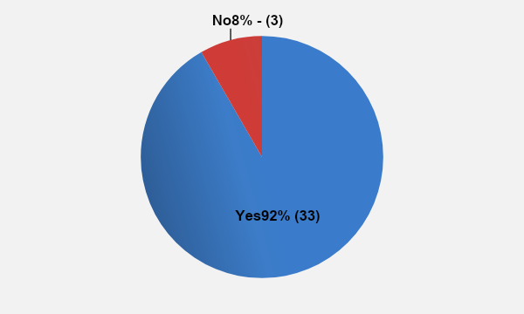

**Figure 1: Persons Who Previously Heard About IALEIA before the Seminar**

**Table 2: Medium through Which Persons Were Made Aware of IALEIA**

|  |  |  |
| --- | --- | --- |
| **Medium** | **Number** | **Percentage** |
| Employment | 12 | 43% |
| FIAT | 7 | 25% |
| Member of IALEIA | 5 | 18% |
| Through association with member | 2 | 7% |
| Google | 1 | 4% |
| Training with embassy | 1 | 4% |
| **Total** | **28** | **100%** |

1. **Current IALEIA Member**

Most of the persons who attended the seminar and responded, were current members of IALEIA (67%), while 33% were not members at the time.

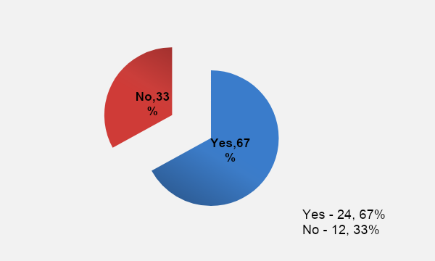

**Figure 2: Current IALEIA Members**

1. **Completed FIAT**

Persons were also asked whether or not they completed the FIAT training at the time, to which 72% indicated yes and 28% indicated no. Notably, only one respondent who indicated that they were currently a member of IALEIA, did not complete FIAT. Of the 12 persons who were not members, 3 completed FIAT.

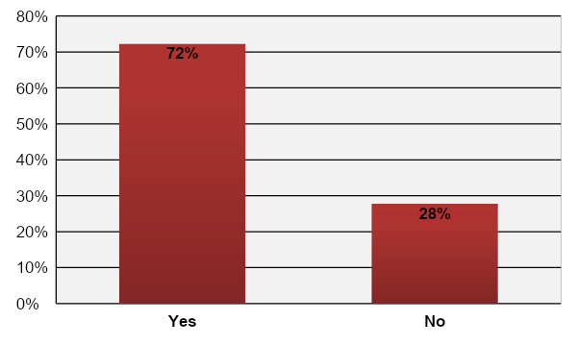

**Figure 3: Persons who Completed FIAT**

1. **Experience, Qualifications and Training Done in Analysis**

Respondents were asked to list their experience, qualifications and training that they have in analysis. Most of the respondents indicated that they have prior work experience in the field (30%), related training (32%) and they attended FIAT (28%), see below for examples of these.

* Work experience ranging from 9 months to over 13 years
* Training:
* Military Intelligence Strategic Course
* Criminal Intelligence Analysis
* Basic Intelligence Training (Military)
* Advanced Tradecraft Course
* Open Source Training
* IBM i2
* REDTRAC
* Arc GIS
* Qualifications/Professional Certifications
* CICA

**Table 3: Experience, Qualifications and Training Persons Have in Analysis**

|  |  |  |
| --- | --- | --- |
| **Experience, Qualifications, Experience** | **Number** | **Percentage** |
| Work Experience | 18 | 30% |
| Training | 19 | 32% |
| FIAT | 17 | 28% |
| Qualifications | 3 | 5% |
| In-house Training | 2 | 3% |
| Instructor in Intel Analysis | 1 | 2% |
| **Total** | **60** | **100%** |

1. **How Analysis is Viewed in Organizations**

Respondents were asked to detail how analysis is viewed in their organization/agency. Several persons indicated that they operate as criminal/intelligence analysts within their organization, which is a core function and as such intelligence analysis is deemed to be important and viewed with great respect. Below are some strengths and weaknesses identified.

**Strengths:**

* Analysis allows for operational activity/planning and other decision-making around criminal activities.
* Convert mass information into intelligence products.
* It is the way forward in policing and tracking organized crime.
* Helps to strengthen cases to go before the courts.

**Weakness:**

* The level of confidence operational team place in intelligence products is not high.
* Disparity with the justice system and the intelligence field.
* Analysis is time consuming.
* Limited access to data and timely responses.
* Need for greater exposure and awareness, especially in security-related degrees.
* Lack of advanced analytical tools.
* Not allotted sufficient resources to include human resources.
* Managers do not fully appreciate challenges faced by analysts.
* Not a lot is being done in the field to ensure continuity of skills.

1. **Analytical Tradecraft Used to Full Potential in Current Role**

Respondents were also asked if their analytical tradecraft was being used to its full potential in their current role, 56% responded yes, it is and 44% indicated no.

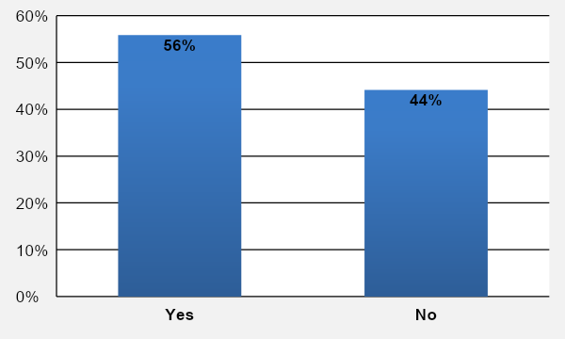

**Figure 4: Analytical Tradecraft Being Used to Full Potential**

For persons who indicated no, the main reason provided was that their current role does not require full use of their analytical tradecraft. Other reasons include the need for more resources, added training and certification and not many tasks coming in from investigators. Some respondents also noted that persons at the supervisory level are not sufficiently trained in the area for them to understand and provide adequate guidance.

Respondents who indicated yes, their analytical tradecraft is being used to its full potential, mainly highlighted that analysis is a core function of their roles within their organizations.

1. **Assistance/Training Needed to Develop Analytical Skills**

Respondents listed a number of areas that they would like assistance and training in, to further develop their analytical skills, see below.

* Open source training
* FIAT training
* Strategic analysis
* Counter surveillance
* CICA Training/Certification
* FIAT Instructor training
* Cybercrime intelligence analysis
* Financial analytical training
* Writing and presentation training
* Analyst managerial skills
* Training in intelligence to evidence development
* Specialized training such as spatial intelligence data analysis
* Advanced training in the field with the various technologies
* More certified courses internationally and locally so as to keep current
* Networking opportunities
* More seminars and workshops
* International exchange programmes

1. **How IALEIA and IALEIA Jamaica Chapter Can Assist in Developing Skills**

Respondents also indicated how IALEIA and IALEIA Jamaica Chapter can assist in developing their skills.

* Providing networking and training opportunities
* Registering persons to become members
* Host more stakeholder conferences, seminars and workshops to share ideas and approaches
* Allow for exchange programmes with other agencies/countries
* Keep abreast of developments and expose members to them
* Advertise and facilitate continuous upgrades and training
* Facilitate communication with other IALEIA members locally and internationally to share ideas

1. **Sufficient Analytical Training Within Organization/Region**

A significant percentage of the respondents indicated they feel that training within their organization/region was not sufficient (78%) and a smaller Percentage indicated that it was (22%).

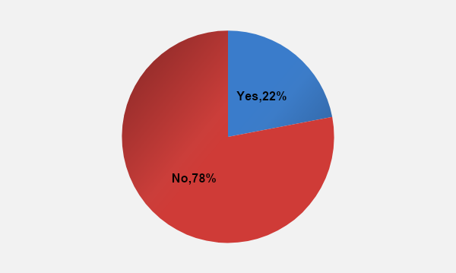

**Figure 5: Sufficient Analytical Training within Respondents Organization/Region**

1. **Sufficient Mentorship After Training**

A small percentage of respondents indicated that after they receive training, they feel that they will have sufficient mentorship (26%). That means that the majority of the persons feel that they will not have sufficient mentorship subsequent to training (74%).

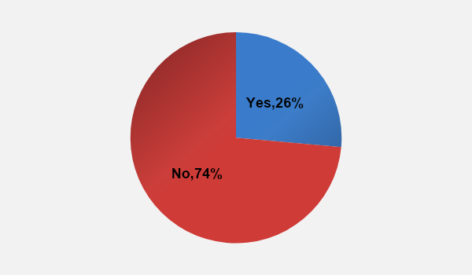

**Figure 6: Sufficient Mentorship Received After Training**

1. **Aware that IALEIA Offers Certification in Analysis**

Persons were also asked to indicate whether they were aware that IALEIA offers certification in analysis and 83% indicated that yes, they did know while 17% indicated that they did not. Notably, a small percentage of the persons who did know that IALEIA offers certification, were aware of the steps to take to receive same (40%); which means the majority of the respondents were not aware of the steps to take to receive IALEIA certification (see Figures 7 and 8 below).

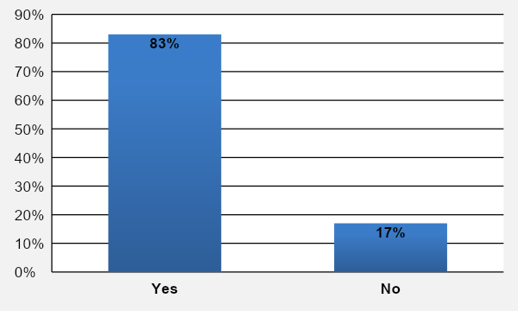

**Figure 7: Persons Awareness about IALEIA Certification in Analysis**

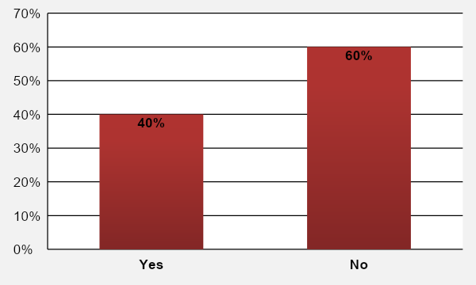

**Figure 8: Knowledge of the Steps to Receive Certification**

**SUMMARY OF FINDINGS & ANALYSIS**

Over half of the persons who attended the seminar and responded to the questionnaire were Analysts (57%), followed by Supervisors (20% or 7).

**IALEIA**

Majority of the respondents had previous knowledge of IALEIA before attending the seminar (92%) and mostly learnt of it through their employment (43%) and completion of FIAT (25%).

Of the 36 respondents, 67% were current members of IALEIA and 72% had completed FIAT. It should be noted that there was 1 member of IALEIA who did not complete FIAT, as well as 3 persons who were not members but had completed FIAT. Additionally, the majority of persons knew that IALEIA offers certification in analysis. However, not a lot of these persons know the steps to acquire such certifications.

These figures could possibly suggest that when such seminars are held, stakeholders are to be encouraged, invited and assisted to become members, sign up for FIAT and other training/certification; as there is a cross-section of stakeholders who are not members or who have not completed FIAT and other training/certification.

**Analysis/Analytical Tradecraft/Skill Sets**

Persons who attended the seminar had a range of years of experience in the field, from 9 months to over 13 years, as well as various training and qualifications in the field.

Overall, respondents felt that analysis is viewed positively in their respective organizations and that it is a core function. They identified several strengths and weaknesses of analysis to mainly include that analysis guides planning and decision-making while on the other hand it is time consuming and there are challenges with resources, especially human resources.

However, just over half of the respondents indicated that their analytical tradecraft was being used to its full potential in their organizations (56%). The main reason provided by those who felt their tradecraft was not being used fully (44%) was that their current role does not require full use of their analytical tradecraft.

**Training**

Importantly, the majority of the respondents felt that there was not sufficient analytical training within their organizations/region (78%). Additionally, only a small percentage of respondents indicated that they feel they will have sufficient mentorship after receiving training (26%).

Persons highlighted several areas that they would like assistance with and training in, to further develop their analytical skills. These mainly include having more seminars, workshops and training to provide networking opportunities, advanced and up-to-date training in the field, as well as local and international certifications. There were some interests for completion of FIAT and FIAT Instructor training.

When asked how IALEIA and IALEIA Jamaica Chapter can assist in developing their skills they also indicated their wish for more seminars, workshops and training to provide networking opportunities, share ideas and to keep abreast of developments in the field. Persons also expressed interest in having exchange programmes with local and international agencies to be exposed to different approaches and uses of analytical tools.

1. The International Association of Law Enforcement Intelligence Analysts (IALEIA)
2. Foundations of Intelligence Analysis Training (FIAT)